**Redback Operations**

**IoT Sensor Research and Development Team**

**By**

**Sharni Sujatha**

**(Leader of IoT Sensor Research and Development Team)**

1. **Exercise Bikes**

Exercise bikes are great workout for everyone as it is a low-impact option for both cardio and strength training. Exercise bikes promote longevity because they're safer on the joints while improving cardiovascular health. Exercise Bikes are categorized based on their style and often offer different levels of resistance and durability.

Types of Exercise Bikes:

* Upright
* Recumbent
* Indoor
  1. 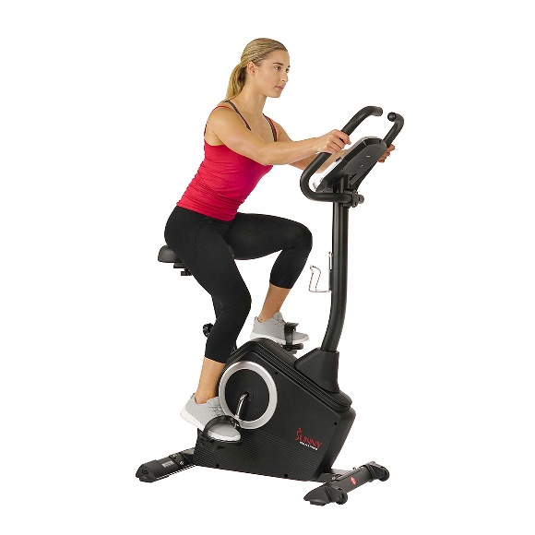**Upright Bikes**

Upright bikes encourage you to sit in an upright position and are devised for you to switch between a sitting and standing position, much like an outdoor road bike. The pedals are positioned directly under your bodywith a forward lean position promoted to reach the handlebars. Seats in an upright bike are narrower in size which allows your legs to move freely.

But, the size of the seats combined with the lack of back support might be uncomfortable. A study [2] on stationary bikes found that the muscles that play a vital role in our mobility are engaged more during upright pedalling. Some upright bikes also feature movable handlebars that allow you to work your upper body while cycling.

* 1. 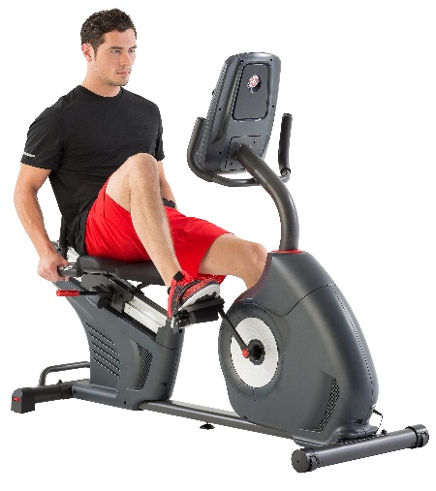**Recumbent Bikes**

Recumbent bikes have a wider seat and a reclined position along with back support. It is also positioned lower to the ground than other types of bikes, making getting on and off easier. Also, its recline results in less stress on the joints because the pedals are further forward. These bikes provide a serious cardio and a focused lower body workout depending on your speed, resistance, and workout time. However, the fact that it has one fixed position and offers less core recruitment makes it a less ideal choice of exercise bike.

* 1. **Indoor Bikes**

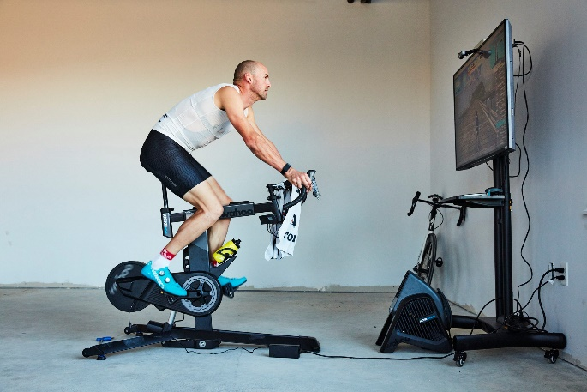

Indoor bikes mimic the experience of outdoor cycling and are built for fast pedaling and burning calories. They usually have a built-in resistance knob, adjustable seats and handlebars so the rider can sit or stand while riding just like on a road bike. However, having a poor form while exercising with indoor bikes can lead to injuries. There is also an option to use the pedal, a cage strap, or cleat clip-in shoes, the latter especially useful for those training for longer distance competitions.

1. **Features**

This section contains the features to look for when choosing an exercise bike.

**2.1. Cadence and Speed**

Cadence is the number of revolutions of the crank per minute, this is the rate at which a cyclist is pedalling/turning the pedals. If one foot pedals a full circle about once every second, you are cycling cadence is 60 rpm. Cadence is usually recorded with a cadence sensor attached to the pedal crank. A cadence sensor measures the rotational speed of your pedals (in RPM).

Speed is different from cadence as it measures the speed of the bike. This is recorded from a speed sensor attached to the wheel of the bike. The speed sensor will use the circumference of the bike’s wheel to determine the speed and distance travelled.

* 1. **Resistance**

To simulate the feeling of riding an actual road bike, there are several different ways exercise bikes provide resistance while you pedal. There are different types of resistances available in exercise bikes as listed below.

* Brake-Based Systems
* Direct Contact Resistance
* Magnetic Resistance
* Fan/Air Based Resistance

**2.2.1. Brake-Based Resistance**

This is the most basic kind of resistance on the market, as it employs the same technology used to stop or slow down conventional bikes. It uses a controlled braking mechanism to raise or decrease resistance in the same way. To produce resistance, this braking system applies friction to the exercise bike's wheel. There are a variety of braking systems designed expressly for this purpose, including hydraulic disc brakes, drum brakes, coaster brakes, and so on.

**2.2.2. Direct Contact Resistance**

It works on the principle of friction and uses a brake pad to apply direct contact to the bike's flywheel in variable amounts to achieve the desired resistance intensity. One can adjust the resistance created by the bike using the brake pads. These bikes are preferred because they come in a variety of difficulty levels, from beginner to advanced and can produce high levels of resistance, that will challenge even the most experienced riders.

However, bikes with this type of resistance are high maintenance and noisy. Over time, The friction between the brake pad and the flywheel creates mechanical wear and tear over time. So, getting this bike will mean incurring additional expenditures to repair the repetitive damage on top of the initial investment.

**2.2.3. Magnetic Resistance**

Bikes with magnetic resistance create a powerful resistance with the help of the flywheel and two strong magnets. The magnets are positioned on either side of the flywheel but never make contact with it. As one rides the bike, the rotation of the flywheel disrupts the magnetic field. This attraction creates resistance which makes it more difficult to peddle. When a more elevated level of resistance is needed, a knob is turned to bring the magnets closer to the flywheel and vice versa. Since the magnets are not in direct contact with the flywheel, there is no mechanical wear and tear that would need replacement on a regular basis. It also allows the rider to customise the workout by allowing them to control the level of resistance accurately.

**2.2.4. Fan/Air Based Resistance**

A fan replaces the traditional flywheel on this type of exercise bike. When you increase your pedalling speed, the fan has to churn out more air, which results in increased resistance. When you slow down your pedalling, the fan needs to move through less air, resulting in less resistance. These bikes are comparatively less noisy and require very little to no maintenance. A major drawback of these bikes is that since the only way to increase the resistance is by speeding up, some users might find it less beneficial due to its lack of customizable capacity.

**2.3. Power Output**

Power output is measured in Watts and gives an idea of how much power the rider is exerting. Power meters typically work by measuring the force on a component (pedal axle, crank arm, spider) using strain gauges. They then convert this to power by multiplying it by the angular velocity (or cadence) of that component. Pedal power meters are more accurate than crank and hub power meters.

**References**

[1] "There's an exercise bike for every fitness goal.", *Verywell Fit*, 2022. [Online]. Available: https://www.verywellfit.com/what-are-the-different-types-of-exercise-bikes-5191451

[2] A. D. Lopes, S. R. Alouche, N. Hakansson and M. Cohen, “Electromyography during pedaling on upright and recumbent ergometer,” *International journal of sports physical therapy*, vol. *9, no.* 1, pp. 76–81, 2014.

[3] "Different Resistance in Exercise Bike", *PowerMax Fitness*, 2022. [Online]. Available: https://www.powermaxfitness.net/different-resistance-in-exercise-bike-bd-118.html

[4] "Best power meters in 2022 | Top-rated power meters and buyer's guide", BikeRadar, 2022. [Online]. Available: https://www.bikeradar.com/advice/buyers-guides/best-power-meters/

[5] "How to Choose Between Hub-, Pedal-, and Crank-Based Cycling Power Meters", CTS, 2022. [Online]. Available: https://trainright.com/5-important-factors-choosing-power-meter/